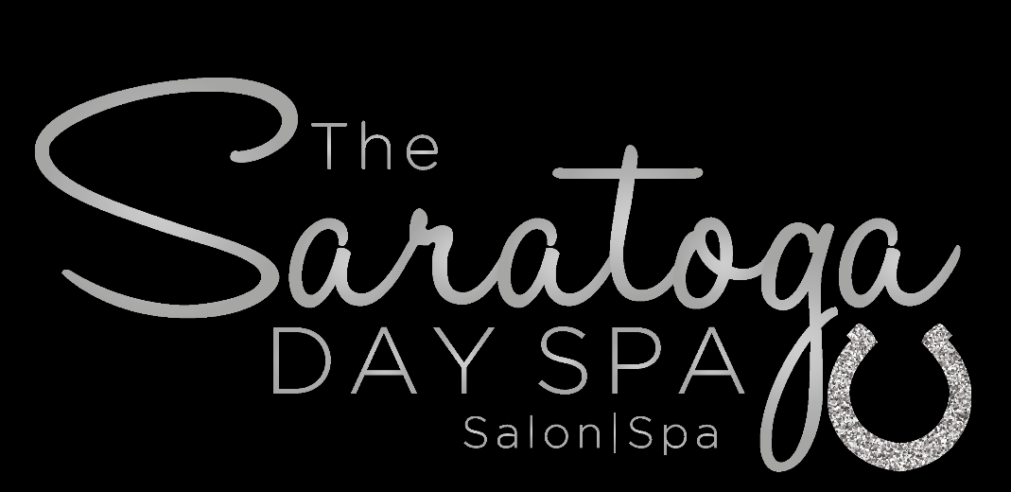
376 Broadway Suite 21A
Saratoga Springs, NY 12866
Kelley Marsh
Owner and Para Medical Esthetician
518-320-6239
MONTHLY MEMBERSHIP CONTRACT
Win: $125 Monthly Membership☐
Place: $75 Monthly Membership☐
Show: $50 Monthly Membership☐

- Membership dues will be charged to your credit card on the first (1st) day of every month. WE use a secure system for monthly charges.

- Appointments at The Saratoga Day Spa are made on a first-come, first-serve basis. You are responsible for scheduling your monthly spa service(s) in advance to ensure that you receive your preferred date, time and service provider. We also have online booking available at www.vagaro.com/thesaratogadayspa

- Per our Cancellation Policy, please provide 24 hours’ notice of appointment cancellation to avoid being subject to a No-Show Fee in addition to your monthly membership dues.

- Spa membership dues do not include gratuities.

- Please carefully review and follow all Spa Etiquette Guidelines listed on our website: www.thesaratogadayspa.com

- Gift memberships may be purchased at any time. Ask your therapist for details.

- Facials do not roll over month to month. If an appointment is missed and/or cancelled you must rebook within the same month.

- Monthly memberships may not be used in combination with any other promotional offers or packages, discount coupons or gift certificates.

- To cancel your membership, please provide The Saratoga Day Spa a 30-day written notice and are effective 30 days after the date received. Payments due prior to the effective date will be charged as scheduled.

- The Saratoga Day Spa reserves the right to cancel any membership at any time.

- The Saratoga Day Spa reserves the right to adjust membership pricing or membership services with a 30-day written notice.

- You are going into a VIP Monthly Facial service with Kelley Marsh. These monthly services are not transferable to any other therapist at The Saratoga Day Spa for other services. Each therapist is an Independent Contractor and are paid by their clients only.

I have read and fully understand the terms and conditions regarding The Saratoga Day Spa’s Monthly
Memberships.
NAME (please print clearly) ______________________________________________________________
SIGNATURE ___________________________________________________________________________
DATE _______________
The Saratoga Day Spa SECURITY POLICY: The Saratoga Day Spa respects our customers’ right to privacy and need for securely stored information. We have appropriate security measures in place in our spa facility to protect against the loss, misuse or alteration of information that we have collected from you.
The Saratoga Day Spa does not share our customer information with third-party vendors.
IF YOU HAVE ANY QUESTIONS REGARDING YOUR MONTHLY SPA MEMBESHIP, OR WOULD LIKE TO SCHEDULE AN APPOINTMENT, CALL
Kelley Marsh 518-320-6239 or kelleymarsh@thesaratogadayspa.com
START DATE___________CARD ON FILE ________________________________ AUTH INITIAL _______

